Website screen

Index page there is there are 3 posts here I only showing the first post with header part of last post with footer.

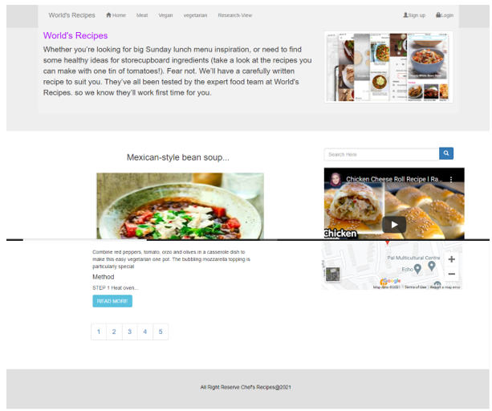

This is meat post page and I have also created two more pages for vegan and vegetarian and all of them are looking same. Here only users can search for relevant data such as meat.

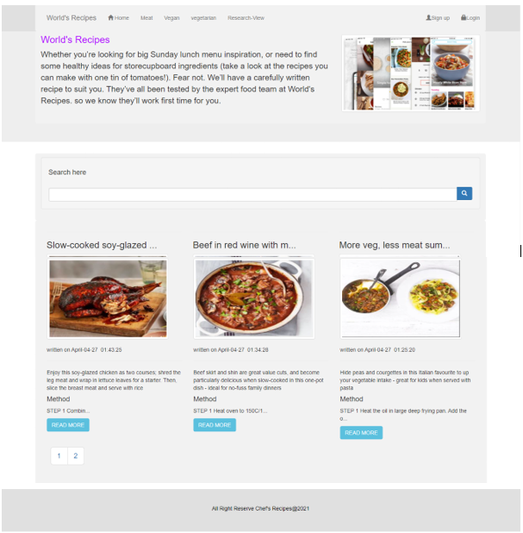

Login page
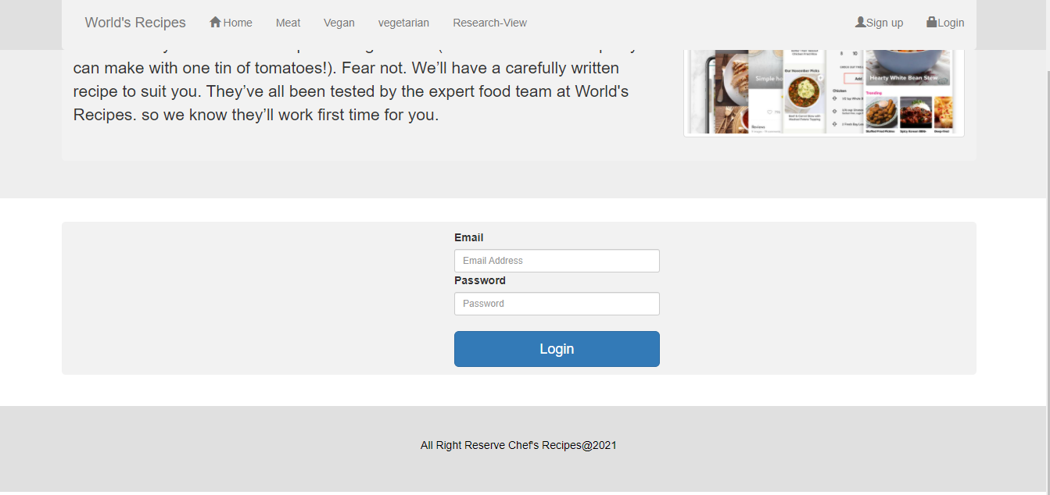

Sign up page

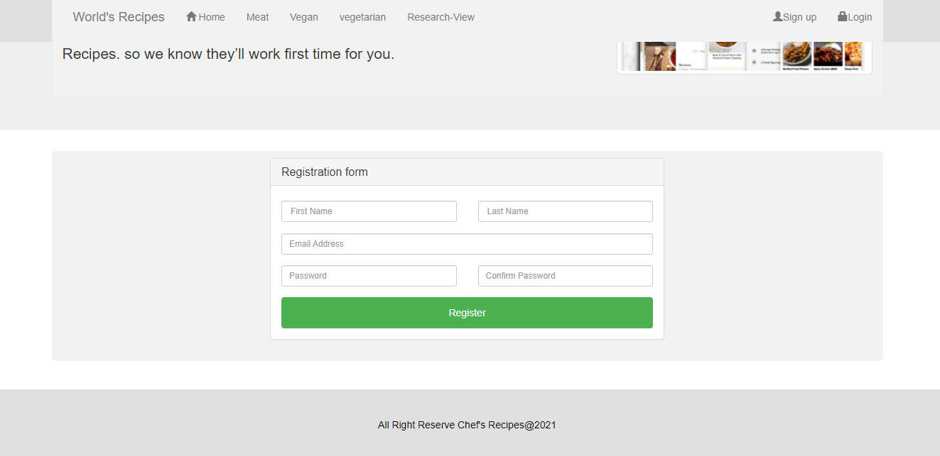

Posts recipes here where user can post recipes.

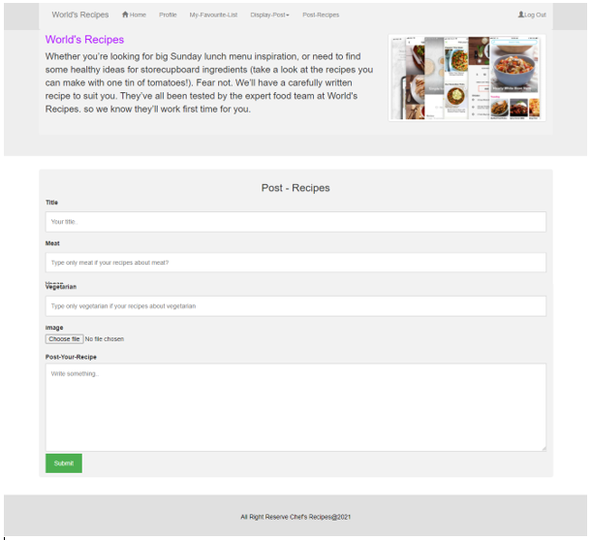

Here where you can edit and delete the post in control plan. I have created three pages one for meat and one for vegan and vegetarian, as well users can search here by title in order to edit or delete etc.

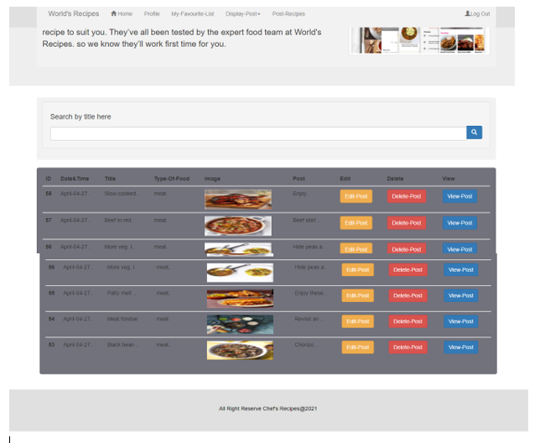

Here where user can find his favorite saved recipes
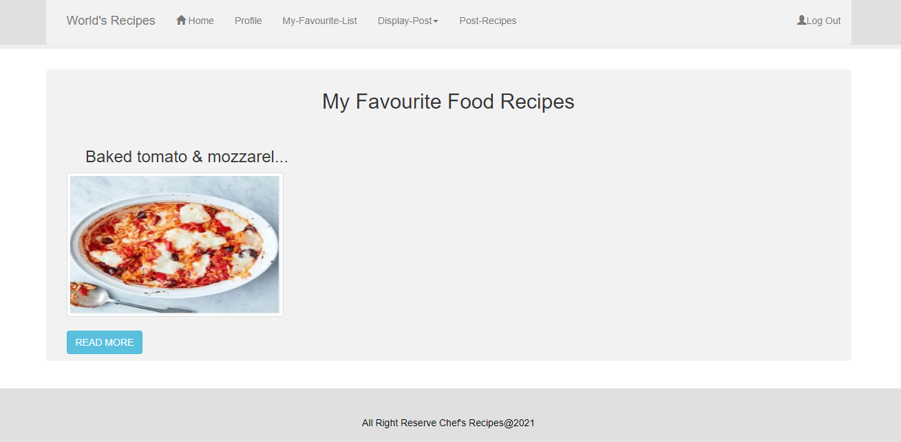

This is how the delete page it will look like all fields are disabled

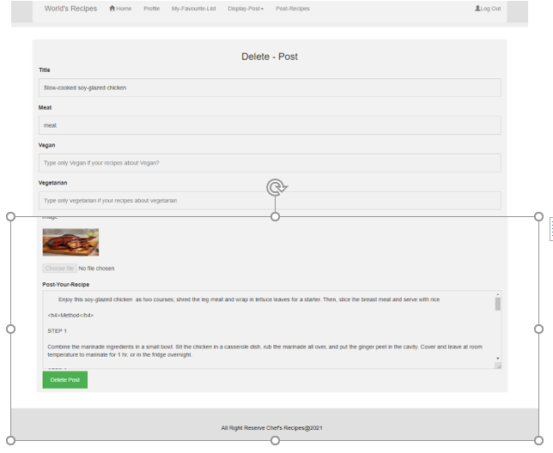

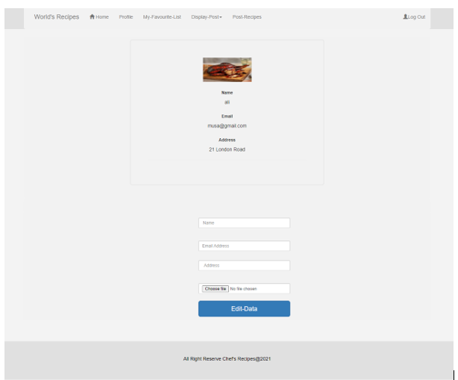

Mobile view design by google chrome (full post)
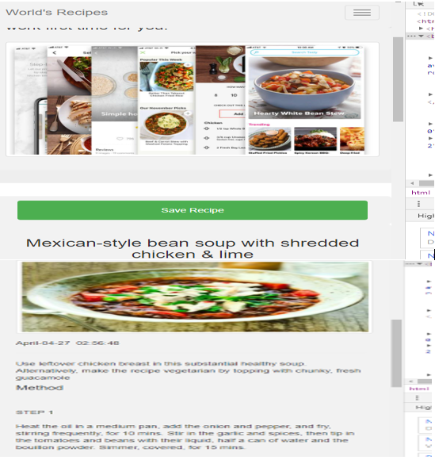
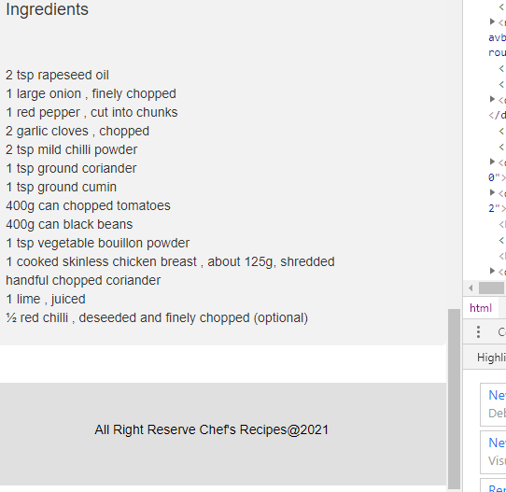

Mobile view design by google chrome (profile users)

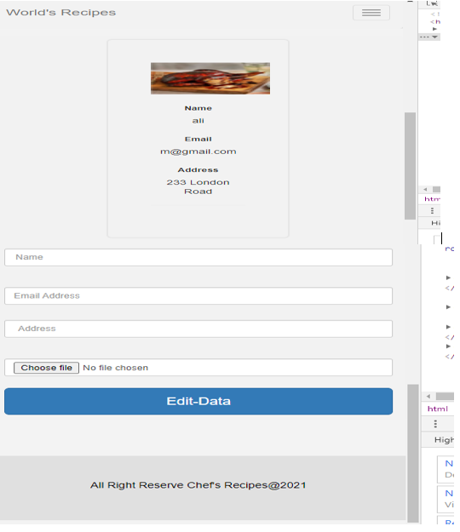

I will publish my website on my own domain.

http://demo.myownprojectnow.com/

